Lab 03: Computer System Hardware
Team Members: Zachary Silver, Samnorp Deung, Myles Sartor, Jumar Demetrius

Background
This week we examined how transistors are used to build logic gates and those logic gates are used to build CPUs, data storage (memory), and data transport (busses). In this lab you will explore transistors, integrated circuits, and the basic logic circuits to develop an understanding of the underlying technologies of computing.

Activity Instructions
The instructions can be found in the Assignment in Canvas.

Questions For Reporting Back
Fill in these questions with the responses that you came up with as a team or that we discussed as a class.

Activity 1: A Single Discrete Transistor
- What year was this transistor designed?
1962

- What is the maximum DC current gain (h_{fe})?
This provides an indication of the single transistor’s switching and amplification capabilities when correctly integrated into a circuit.
300

- What is the name of each pin (also called a “lead”, the wires sticking out), and how can you tell which is which?
Collector (C), Base (B), and Emitter (E). The middle is the base, the arrow points toward the emitter (On the schematic symbol), and the remaining pin is the collector.

- What are listed as some of the applications of this transistor?
The transistor can typically be used for low powered switching applications, various circuits, and general amplification.

Activity 2: An Integrated Circuit

- What year is this chip design from?
1977
- How many pins does this chip have? The pins facilitate the integration of this IC into a broader circuit, such as a computer motherboard, allowing for seamless connectivity.
24
- Assuming 1 transistor is required to store 1 bit electronically (other transistors are needed for other functions on this IC, but we will ignore them for now). What is the minimum number of transistors present on this chip?
The NMOS 16K (2K x 8) UV EPROM would require 16,000 transistors at the very minimum to help store the bits electronically.

- How can you program this chip?
You need to apply a high voltage (VPP) to the programming pin (EP) when selecting the addresses and data you want so that you can ingrain the patterns of the data onto the memory within the chip.

Activity 3: Some Models of Digital Logic Circuits

 | name of the person who led | photos of functioning circuit
Experiment 47 | Zachary Silver | 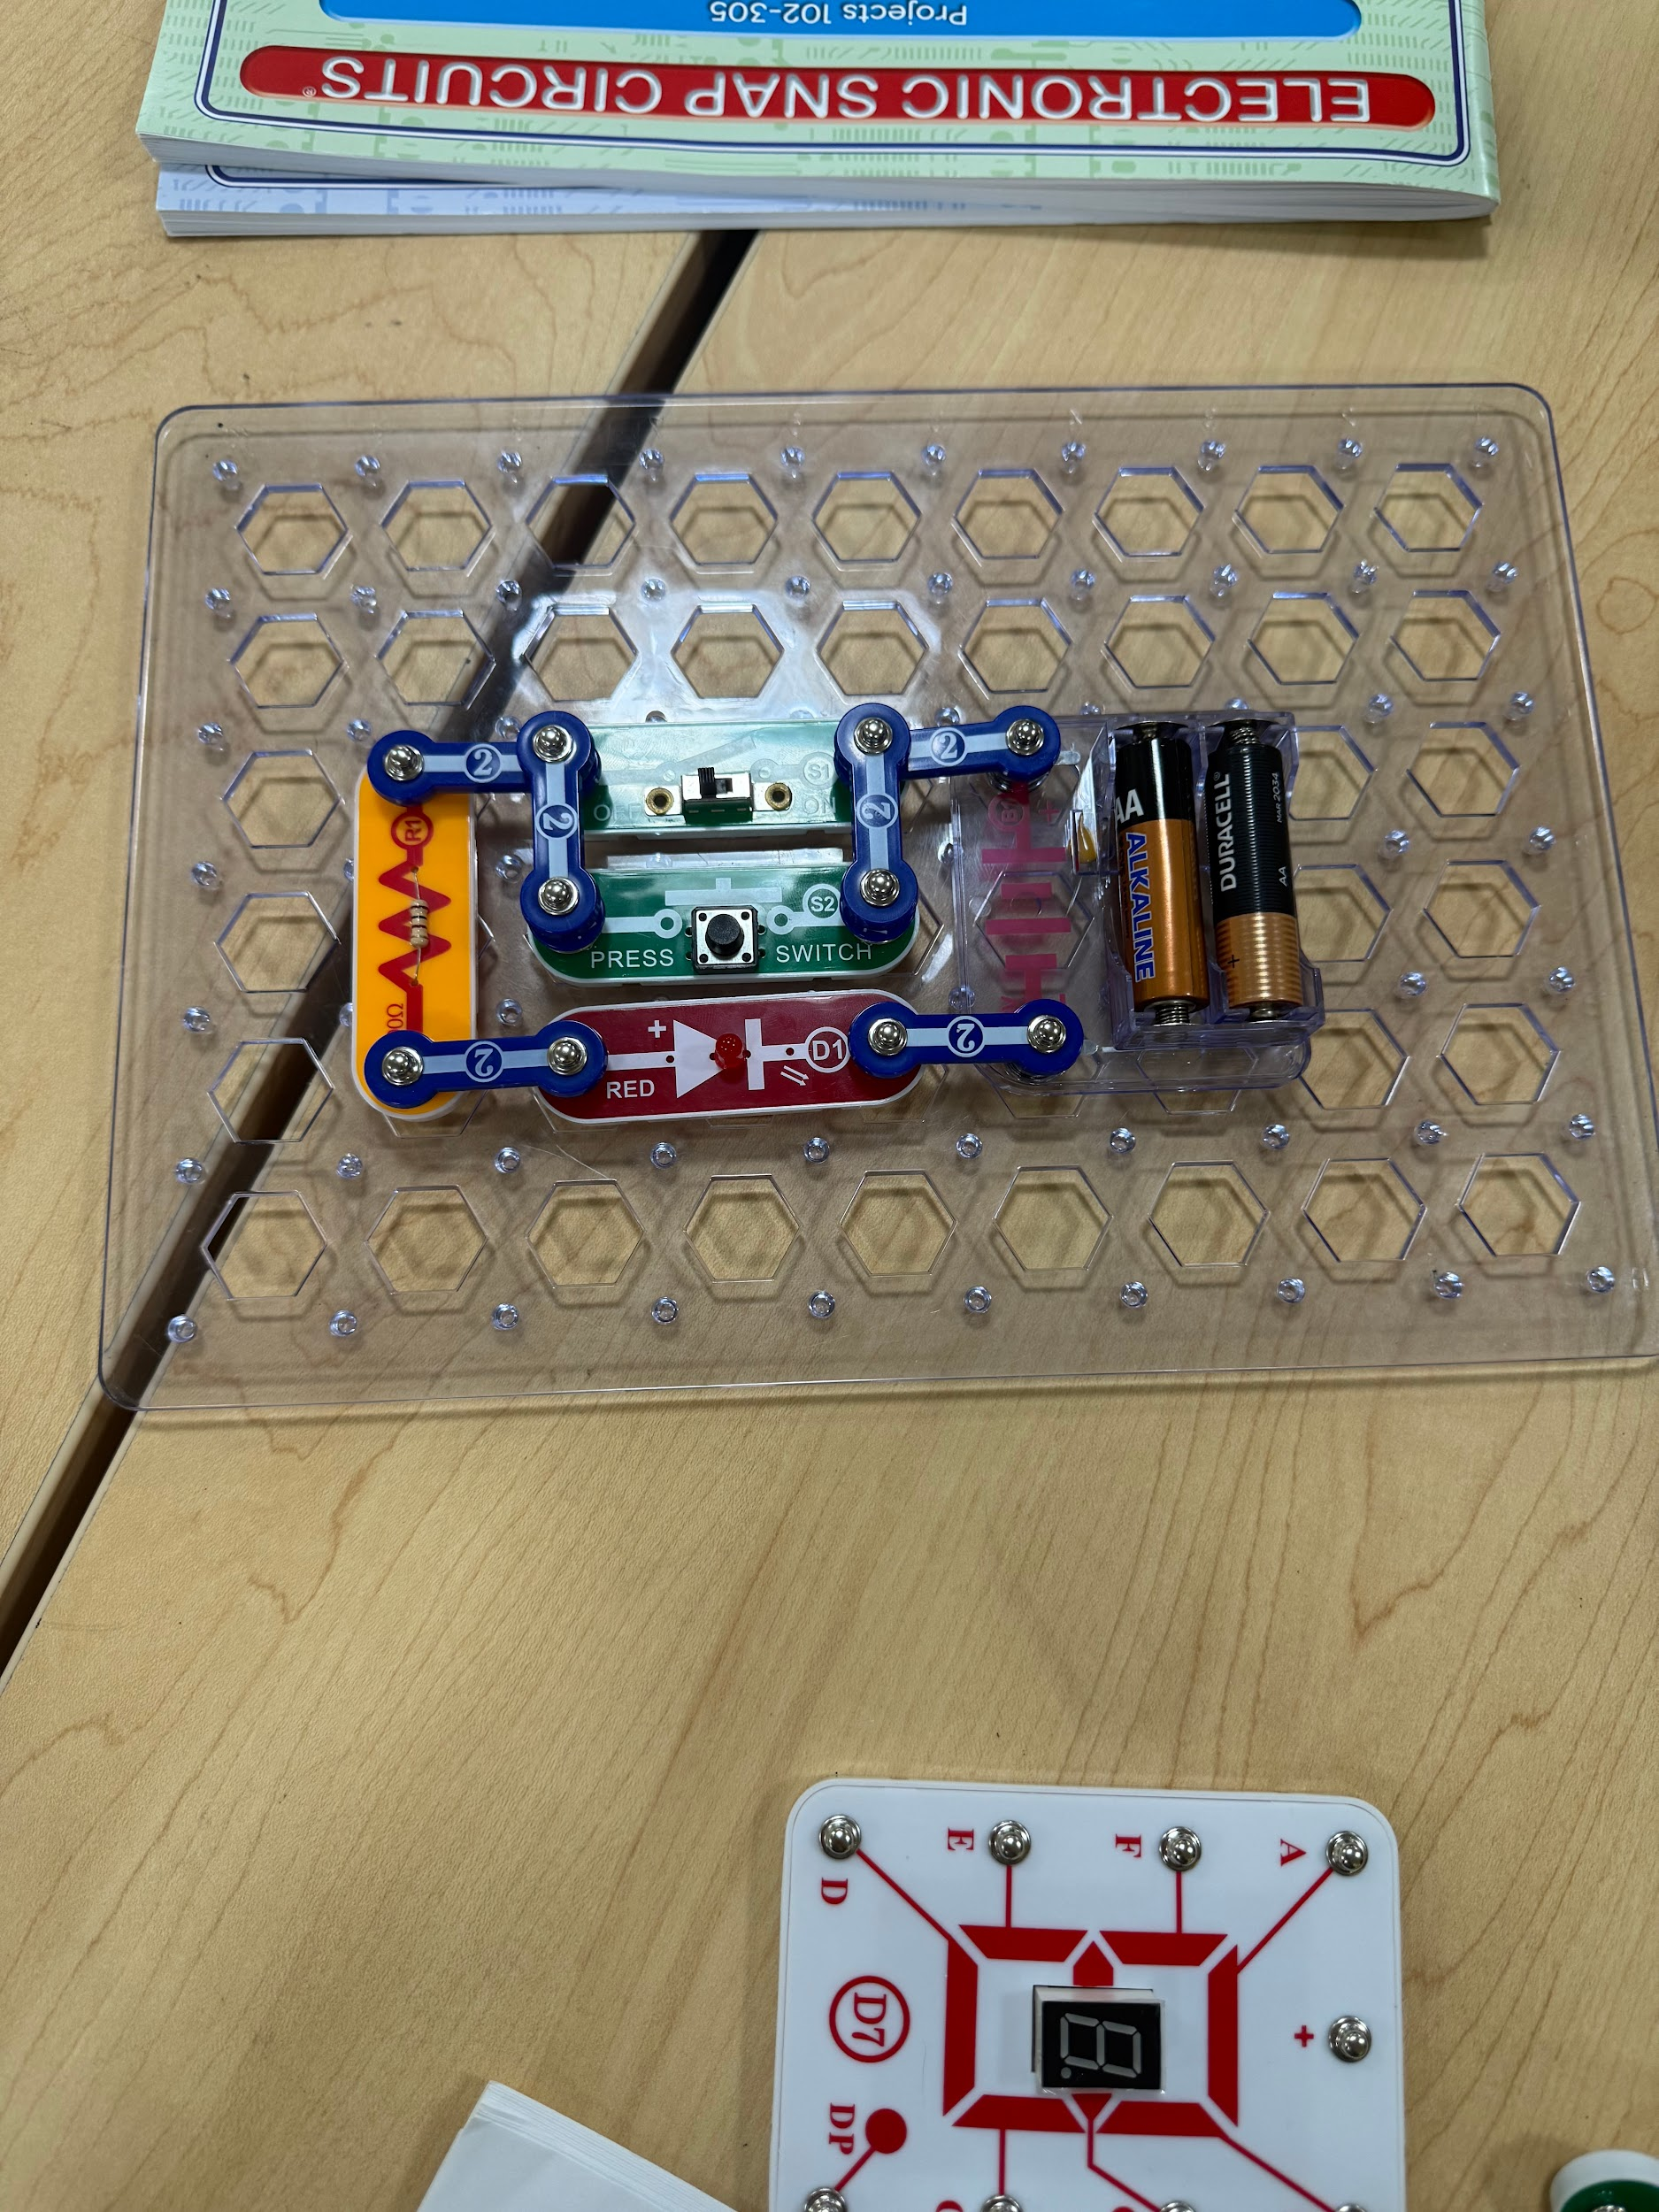
Experiment 48 | Myles Sartor | 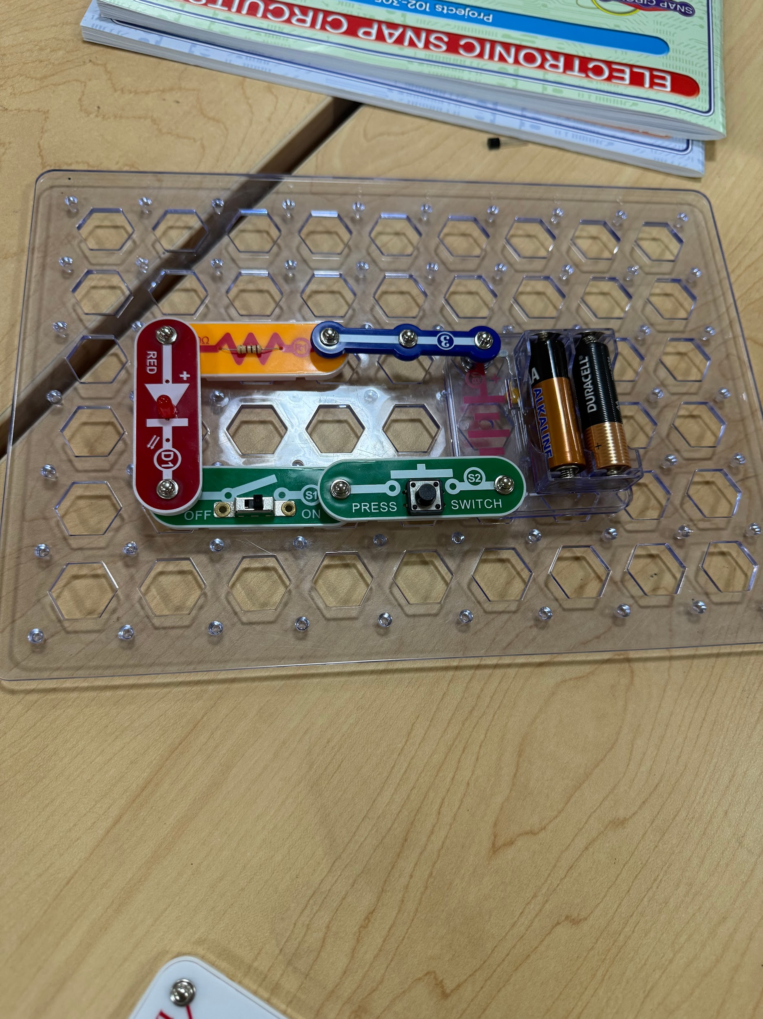
Experiment 49 | Jumar Demetrius | 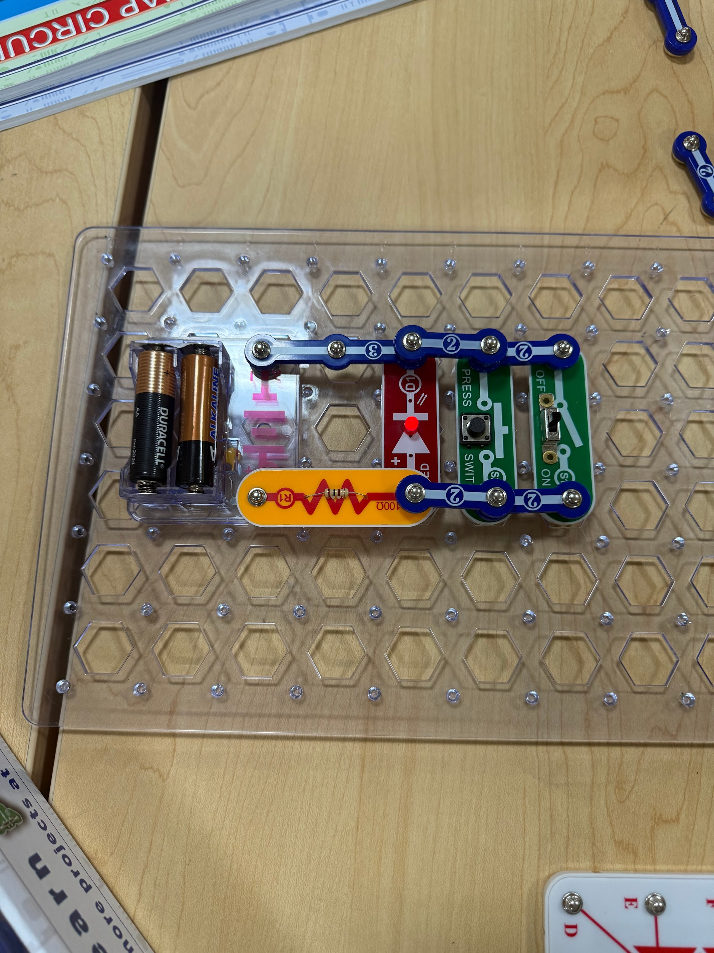
Experiment 50 | Samnorp Deung | 